**Android Application that creates Alarm Clock**

**Procedure:**

**Creating a New project:**

* Open Android Studio and then click on **File -> New -> New project.**

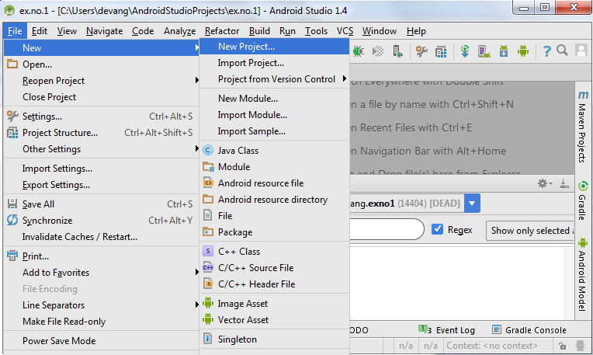

* Then type the Application name as “**SimpleAlarmClock″** and click **Next.**

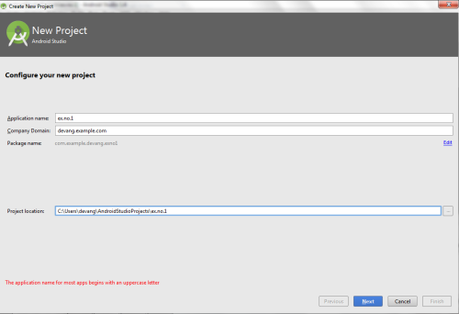

* Then select the **Minimum SDK** as shown below and click **Next**.

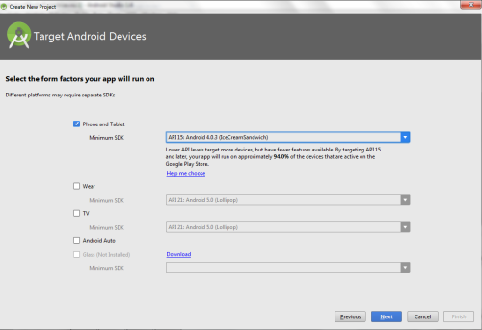

* Then select the **Empty Activity** and click **Next.**

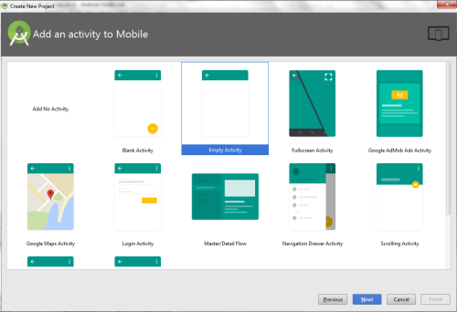

* Finally click F**inish**.

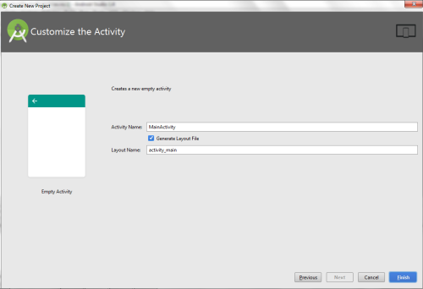

* It will take some time to build and load the project.
* After completion it will look as given below.

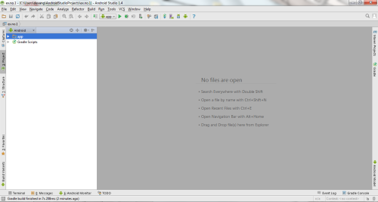

**Designing layout for the Android Application:**

* Click on **app -> res -> layout -> activity_main.xml.**

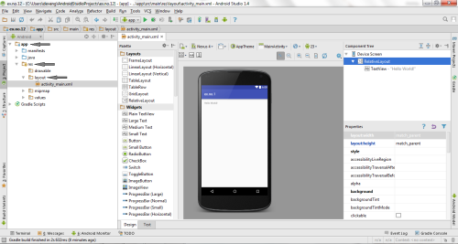

* Now click on **Text** as shown below.

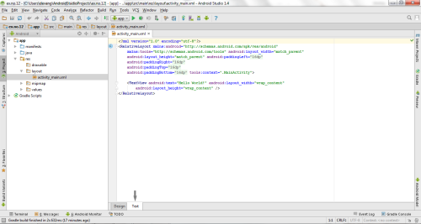

Experiment 10-

**MainActivity.java**

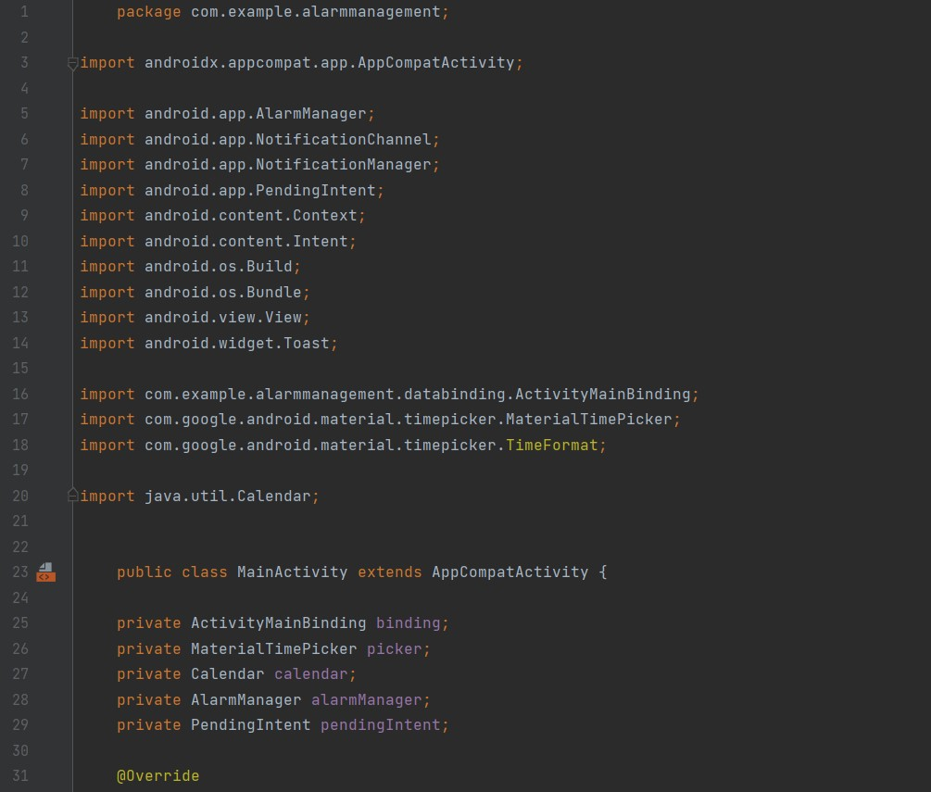

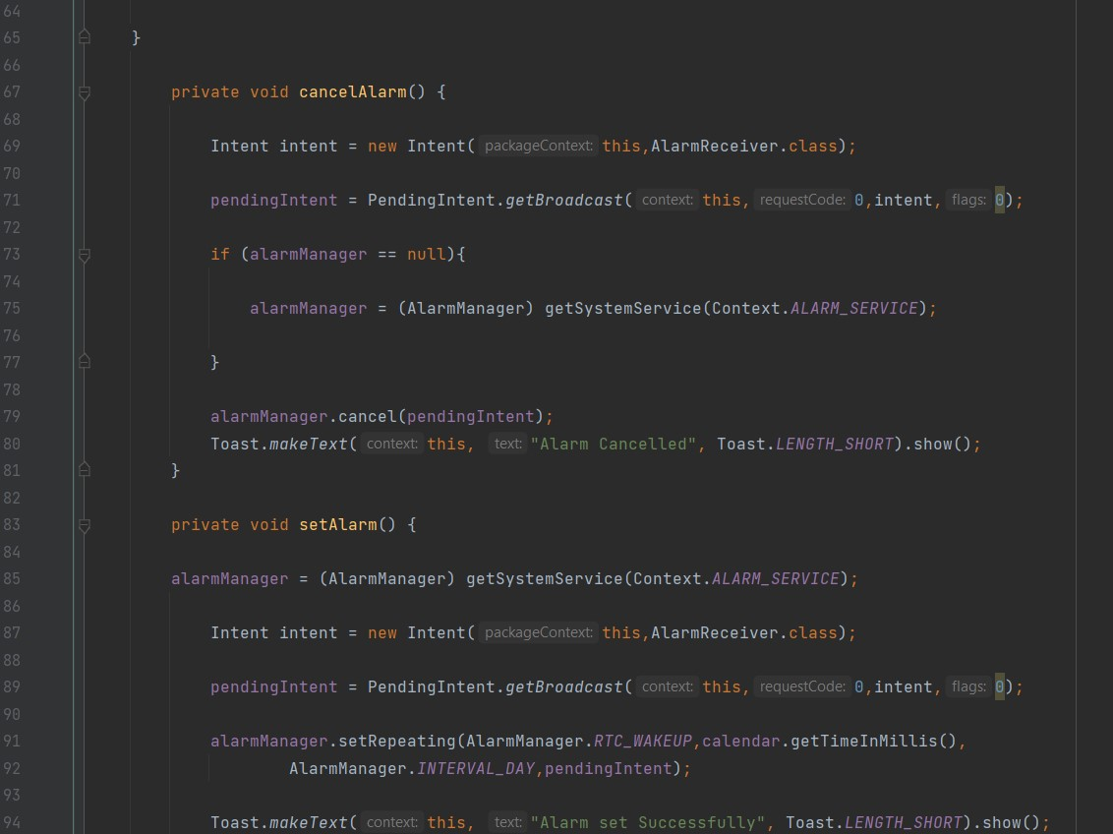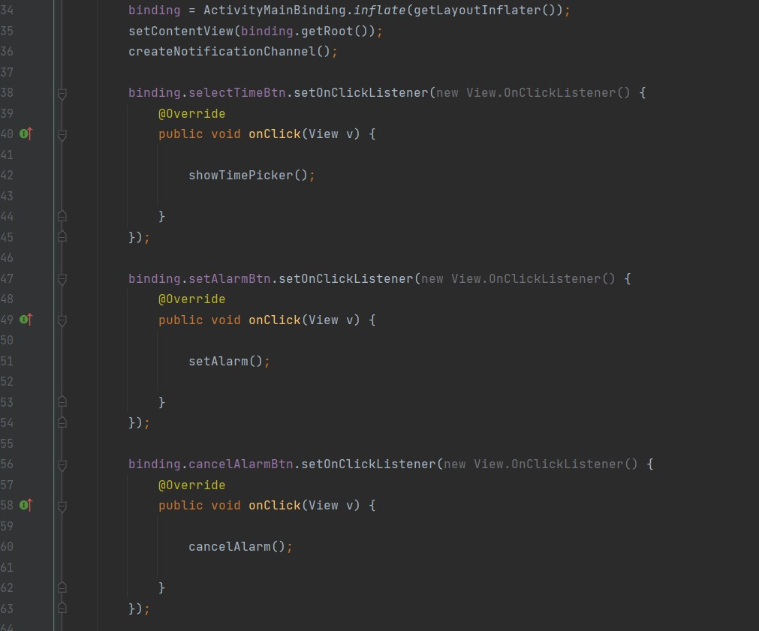

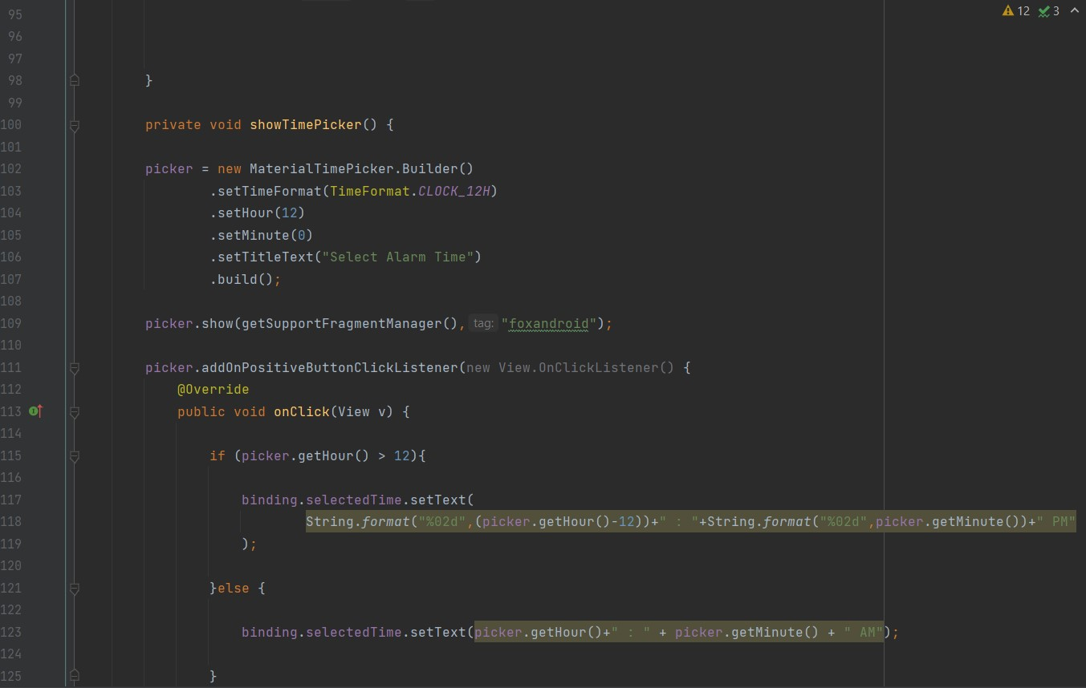

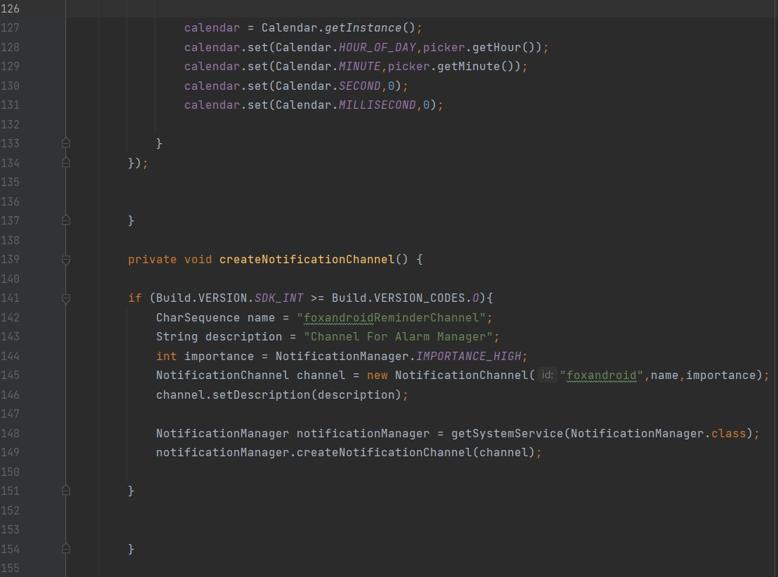

**AlarmReciver.java**

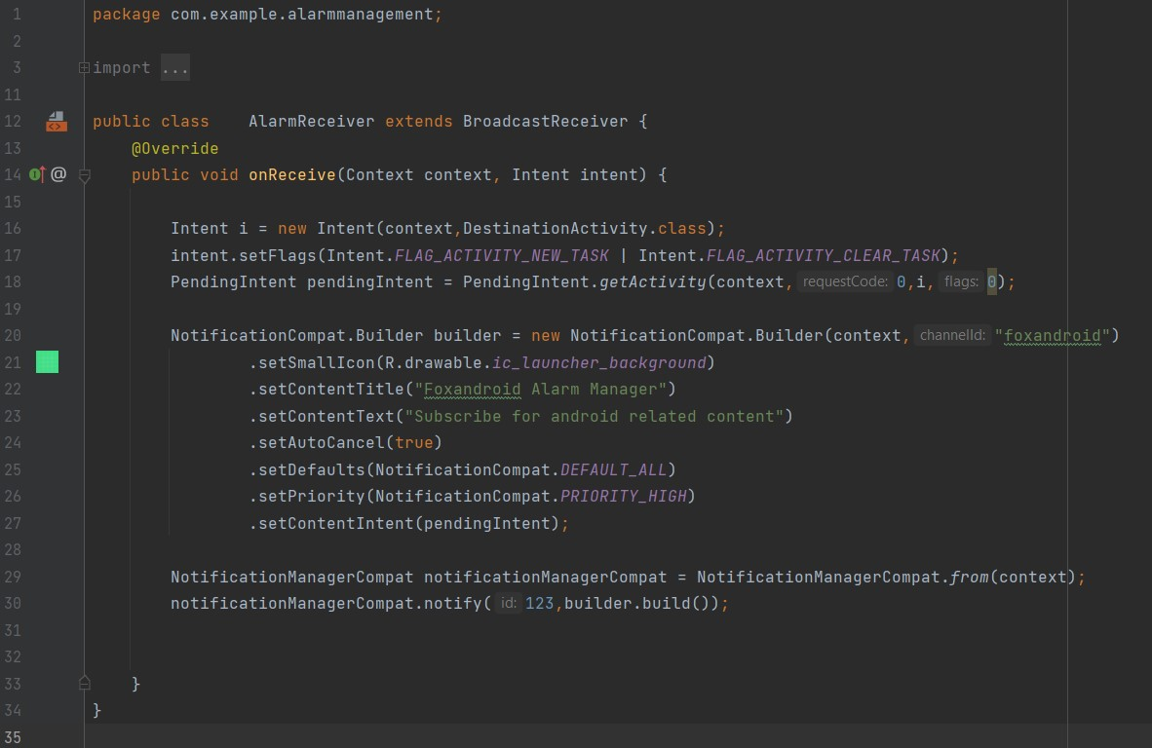

**DestinationActivity.java**

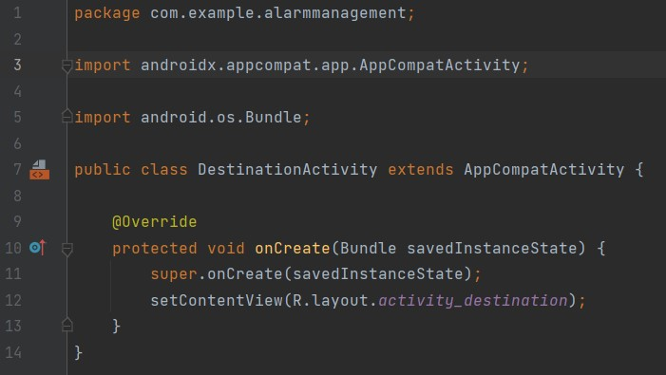

**activity_main.xml**

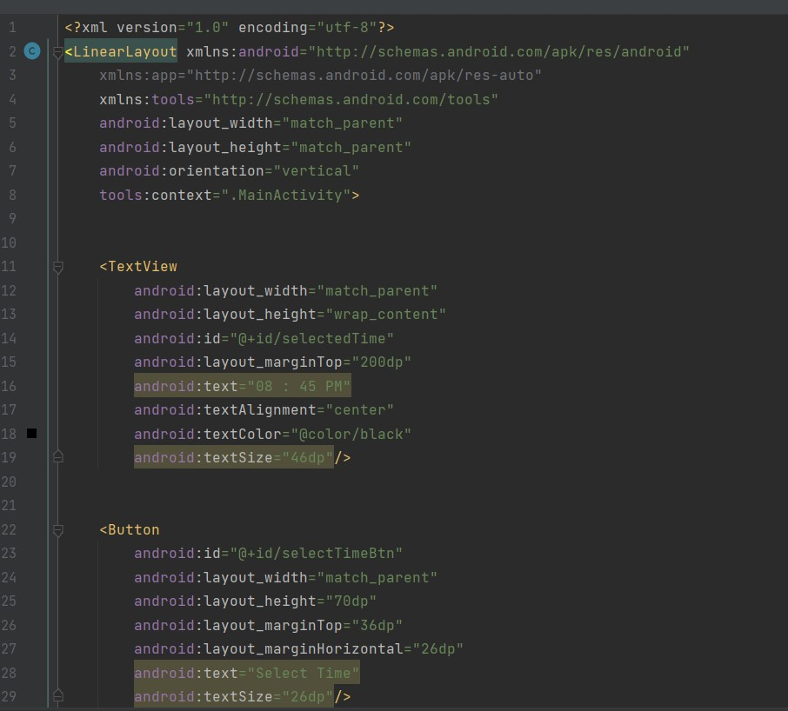

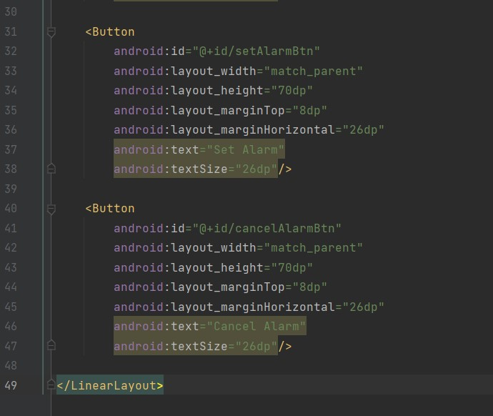

**activity_destination.xml**

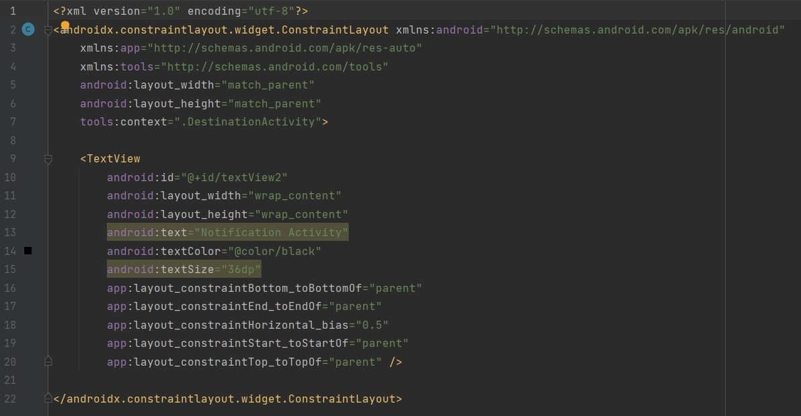

Output-